UAS UTM – LITERATURE SURVEY

**I.** **Unmanned Aerial System (UAS) Traffic Management (UTM): Enabling Low-Altitude Airspace and UAS Operations**

· Describes initial ideas of the UAS UTM.

· Types of UTM systems

o **Portable UTM System**, which will support operations such as **agricultural needs**. The system will be **moved from one area to another easily**.

o **Persistent UTM System**, will support low-altitude **operations that are much more diverse and heterogeneous in nature** based on multiple operators, missions, and range considerations.

· It just documents everything that has happened in the field of UAS UTM and also the scope.

**II.** **From Rural to Urban Environments: Human/Systems Simulation Research for Low Altitude UAS Traffic Management (UTM)**

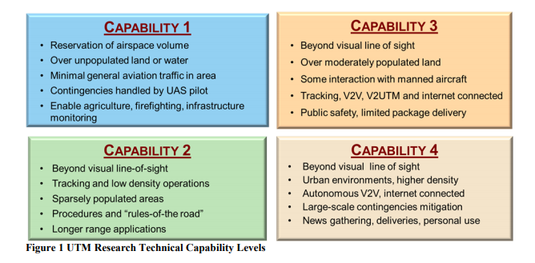

· Test environments of the UAS UTM

· Applications that have been developed for Capability 1 testing

o Mobile

o Desktop

o Interface updates for advanced UTM technical capability levels

**III.** **UAS Traffic Management (UTM) Simulation Capabilities and Laboratory Environment**

· This paper provides an overview of the simulation capabilities currently available as part of the UTM project and the laboratory environment in which they are applied.

· Each TCL(Technical Capability level) is differentiated by the level of risk associated with the assumed environment and the types of operations envisioned

· **Client**

o In the context of UTM, a client is what provides external applications the ability to connect to and interact with the research platform

o Types:

§ Python Client

· Live flight testing and demonstration

· Client **interfaces with the Mission Planner** ground control station application to create operational plans and volumes based on waypoint path definitions

· Establish a web-based connection to the UTM research (**quite dynamic**)

§ Multi-Aircraft Control System

· Interaction between MACS and Google Earth allows for vehicles that are being simulated in MACS to be rendered in Google Earth

· **Interactive Display Applications**

o Google Earth Gateway

§ Allows MACS and google earth to communicate

o UTM Desktop Application

· The desktop application is not limited, however, to simply displaying operations **but allows users to interact with the UTM system through messaging and control of operational states**

· Currently in **redesign phase**

· The MACS client is also capable **of simulating the flight of fixed wing and multirotor UAS** according to the developed profiles while sending position reports.

· **Any number of flights** is able to be operated in **autonomous and manual modes**

o Mobile UTM Application

· Simulation

o Flight Test Support

o Concept Development and Testing

o Live, Virtual, Constructive (LVC) Activities

**NASA UAS TRAFFIC MANAGEMENT NATIONAL CAMPAIGN**

<https://sci-hub.tw/https://ieeexplore.ieee.org/abstract/document/7778080>

**Principles of UTM:**

1) All UAS, operators, and communications are authenticated before use of the airspace.

2) UAS will avoid each other and other objects.

3) UAS will stay separated from manned aviation.

4) All of the constraints, including dynamic constraints for

public safety operations, are available to all stakeholders for

common situational awareness.

5) Access will be fair and efficient.

**Operation:**

An operation is considered as the airspace reservation for TCL 1 category for some finite time for a single vehicle.

**Aspects of Data collection:**

First, overall operation statistics are provided.

Next, data related to the position reports are examined.

Finally, information about the various messages sent and received during the operations is discussed.

**Outcomes:**

The system allowed for common situational awareness across all stakeholders, kept traffic procedurally separated, offered messages to inform the participants of activity relevant to their operations. Over the 3- hour test, 102 flight operations connected to the central research platform with 17 different vehicle types and 8 distinct software client implementations while seamlessly interacting with simulated traffic

**Unmanned Aircraft System Traffic Management (UTM) Concept of Operations**

<https://ntrs.nasa.gov/archive/nasa/casi.ntrs.nasa.gov/20190000370.pdf>

UTM Concept of Operations is mainly concerned with enabling and maintaining operations of large scale small Unmanned Aircraft System (UAS) (typically 55 lb) at low altitudes. Typical small UAS operations include spraying, cargo, surveillance, etc. UAS will use on-board detect and avoid systems to detect other traffic, weather conditions, etc.

**Operating principles for small UAS**

In order to safely enable sUASoperations in the low-altitude airspace, the following operating principles are postulated.

1) Only authenticated UAS and operators are allowed to operate in the airspace

2) UAS stay clear of each other

3) UAS and manned aviation stay clear of each other

4) UAS, their operators or support systems have awareness of all constraints in the airspace and of people, animals and structures on the ground and UAS will stay clear of them

5) Public safety UAS should be given priority over other UAS and manned aviation.